**MC Practicals**

**1. Frequency Reuse (MATLAB)**

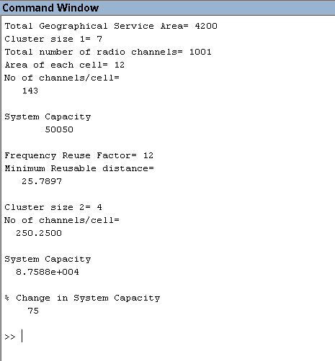clc

clear all

close all

a=input('Total Geographical Service Area= ');

n1=input('Cluster size 1= ');

s=input('Total number of radio channels= ');

acell=input('Area of each cell= ');

*%Part 1*

k1=s/n1;

disp('No of channels/cell= ');

disp(k1);

m1=a/(n1*acell);

c1=m1*s;

disp('System Capacity');

disp(c1);

*%Part 2*

q=input('Frequency Reuse Factor= ');

r=sqrt((2*acell)/(3*sqrt(3)));

d=q*r;

disp('Minimum Reusable distance= ');

disp(d);

*%Part 3*

n2=input('Cluster size 2= ');

k2=s/n2;

disp('No of channels/cell= ');

disp(k2);

m2=a/(n2*acell);

c2=m2*s;

disp('System Capacity');

disp(c2);

change=((c2-c1)/c1)*100;

disp('% Change in System Capacity');

disp(change);

**2. Handoff Algorithm (MATLAB)**

clc

clear all

close all

pr=-85;

ph=-95;

k1=0;

k2=30;

sig=6;

D=50;

d=0:0.1:50;

u1=k1-(k2.*(log(d)));

u2=k1-(k2.*(log(D -d)));

a=(u1-pr)/sig;

b=(u2-pr)/sig;

c=(u1-ph)/sig;

p=(pr-u2)/sig;

e=(u2-ph)/sig;

f=(pr-u1)/sig;

Pout=qfunc(a).*qfunc(b);

Pass1=qfunc(c).*qfunc(p);

Pass2=qfunc(e).*qfunc(f);

figure(1)

subplot(2,2,1)

plot(d,Pout);

subplot(2,2,2)

plot(d,Pass1);

subplot(2,2,3)

plot(d,Pass2);

subplot(2,2,4)

plot(d,Pass1);

hold on

plot(d,Pass2);

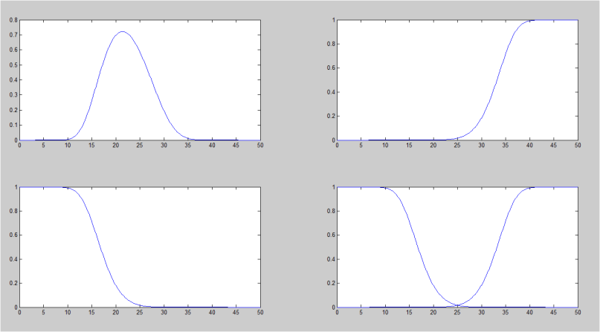

**3. Adaptive Modulation (Simulink)**

**QAM**

**QPSK**

**4. Rayleigh and Rician (Simulink)**

**5. Orthogonal Walsh Code (MATLAB)**

clear all

close all

A=[1 1 0 1 0 0 1];

B=[1 1 0 0 0 0 0];

c=A.*B;

d=sum(c);

if (mod(d,2)==0)

disp("Orthogonal");

else

disp("Not Orthogonal");

end

P=[-1 1 -1 1 -1 1 -1 1];

Q=[-1 -1 1 1 -1 -1 1 1];

R=[-1 1 1 -1 -1 1 1 -1];

S=[-1 -1 -1 -1 1 1 1 1];

l=(P+Q+R+S).*R; ***%try for R; P+Q; P+Q+R as well***

m=sum(l);

n=m/8;

if (n==1)

disp("Message Received")

else

disp("Message Lost")

end

**OUTPUT:**

P+Q will give output “Message Lost”, the rest will give “Message Received”

**6. GSM and CDMA Sums (SCILAB)**

clc

clear all

*//1*

Rb=270833;

Tb=1/Rb;

B=0.3/Tb;

B=B/1000;

mprintf('1) 3dB Bandwidth for Gaussian LPF = %f KHz\n',B);

*//2*

Rb=270833;

C=Rb/0.4;

B=200000;

T=C/B;

SN=(2^T)-1;

SNdB=10*log10(SN);

mprintf('\n 2) The corresponding required theoretical S/N = %f\n',SNdB);

*//3*

C=270833;

B=200000;

BW=C/B;

mprintf('\n 3) Bandwidth Efficiency = %f\n',BW);

*//4*

B=1250;

R=9.6

SRmindB=3;

SRmaxdB=9;

SRmin=10^(3/10);

SRmax=10^(9/10);

Mmin=(B/R)*(1/SRmax);

Mmax=(B/R)*(1/SRmin);

mprintf('\n 4) The IS-95 CDMA system can support %i to %f users',Mmin,Mmax);

**OUTPUT**

1) 3dB Bandwidth for Gaussian LPF = 81.249900 KHz

2) The corresponding required theoretical S/N = 9.754256

3) Bandwidth Efficiency = 1.354165

4) The IS-95 CDMA system can support 16 to 65.258754 users

**7. Radio Propagation Models Sums (SCILAB)**

clc

clear all

c=3*10^8;

***//Q1***

grdb1=5

pt=113

r1=11000

gr1=10^(grdb1/10)

eirp1=pt*gr1

disp('Q1')

disp("EIRP is")

disp(eirp1)

pd1=eirp1/(4*%pi*r1^2)*10^9

disp("Power density in nW/m2 is")

disp(pd1)

***//Q2***

disp('Q2')

f2=800*10^6

ht2=30

hv2=2

r2=10000

Lpm2=40*log10(r2)-20*log10(ht2)-20*log10(hv2);

disp("Path loss using Ray propogation is")

disp(Lpm2)

Lpf2=32.4+20*log10(r2/1000)+20*log10(f2/10^6)

disp("Path loss using Space propogation is")

disp(Lpf2)

***//Q3***

disp('Q3')

pt3=100

l03=30

pt3dbm=10*log10(pt3*1000)

disp("Pt in dB is")

disp(pt3dbm)

pr3dbm=-100

lp3=pt3dbm-pr3dbm

disp("Lp in dB is")

disp(lp3)

r3=10^((lp3-l03)/40)

disp("Radio Coverage in km is")

disp(r3/1000)

***//Q4***

disp('Q4')

fc4=800

ht4=30

hr4=2

lph4=68.75+26.16*log10(fc4)-13.82*log10(30)+(44.9-6.55*log10(ht4))*log10(10)

disp("Free space path loss in dB is")

disp(lph4)

lf4=110.5

disp("Difference between two path loss values in dB is")

dif4=lph4-lf4

disp(dif4)

***//Q5***

disp('Q5')

f5=900*10^6

r5=1000

lam5=c/f5

lpf5=20*log10(4*%pi*r5/lam5)

disp("Free space path loss in dB is")

disp(lpf5)

***//Q6***

disp('Q6')

pt6=10

gt6=9

gr6=4

f6=250

r6=25

tl6=20

pt6=10*log10(pt6*1000)

disp("Pt in dB is")

disp(pt6)

lpf6=32.44+20*log10(r6)+20*log10(f6)

disp("Path loss in dB is")

disp(lpf6)

tcl6=3/100

tloss6=tcl6*tl6

disp("Transmitter antenna cable loss in dB is")

disp(tloss6)

rloss6=0.2

disp("Power Delivered in dBm is")

pd6=pt6+gt6+gr6-lpf6-tloss6-rloss6

disp(pd6)

**Q1**

EIRP is

357.33738

Power density in nW/m2 is

235.0083

**Q2**

Path loss using Ray propogation is

124.43697

Path loss using Space propogation is

110.4618

**Q3**

Pt in dB is

50.

Lp in dB is

150.

Radio Coverage in km is

1.

**Q4**

Free space path loss in dB is

159.50587

Difference between two path loss values in dB is

49.005874

**Q5**

Free space path loss in dB is

91.526622

**Q6**

Pt in dB is

40.

Path loss in dB is

108.3576

Transmitter antenna cable loss in dB is

0.6

Power Delivered in dBm is

- 56.1576